Contact:
Christie Kozak | Leary PR | christie@learypr.com | 978-502-5747

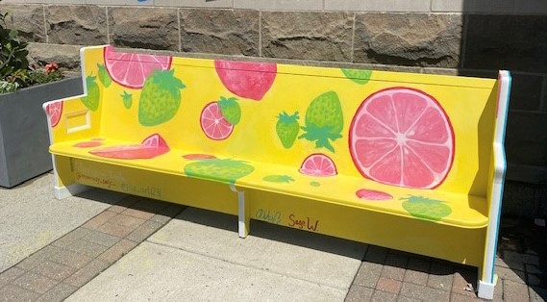

Sit & Let Your Spirit Soar
Public Art Initiative at Chestnut Hill Square

“Pink Lemonade” Bench on Display through October 2022

CHESTNUT HILL, MASSACHUSETTS (June 2022) - Chestnut Hill Square (ChestnutHillSquare.com) has partnered with Newton Community Pride (NCP) to feature the “Pink Lemonade” bench, an art display by Sage Widder, a Newton South High School May 2022 graduate who is one of the winners of the Sit & Let Your Spirit Soar design competition. Sponsored by Newton Community Pride in partnership with the City of Newton, Sit & Let Your Spirit Soar is a public art initiative designed to create community, encourage conversation, and inspire feelings of connection.
“Summer makes my spirit soar. To represent the spirit of summer, I created a ‘strawberry lemonade’ pattern, which combines a traditionally summery drink with a combination of bright, eye-catching colors. Summer is a nostalgic time for me, a time of new beginnings and trying new things. As spring turns into summer, small green strawberries grow and take on a vibrant red hue. Lemons don’t turn pink, but rather the existence of pink lemonade is a fun spin on the more commonly found drink taken directly from the bright yellow lemons. In this way, the design combines the natural charm of the season with the human connect,” says Pink Lemonade designer Sage Widder.
Sit & Let Your Spirit Soar involves the temporary outdoor installation of pews that have been donated by Newtonville’s Boston Chinese Evangelical Church and transformed into three-dimensional functional art by local and regional artists. The decorated pews are strategically located in outdoor public gathering places throughout Newton through October 2022. For more information, visit SitandSoar.org.
“Newton Community Pride is very excited to bring more public art to our city," said Meryl Kessler, chair of Sit & Let Your Spirit Soar and board member of Newton Community Pride. "We hope that this initiative will raise people’s spirits after the challenges of the last two years."

About Newton Community Pride
Founded by volunteers in 1989, Newton Community Pride (NCP) is a non-profit organization building community through free arts and culture programming, beautification projects and volunteerism. Supported solely by community business partners, individual donors and grant opportunities, their mission is to provide public art initiatives, community micro grants and a high school scholarship fund to their portfolio of impactful programs supporting and engaging the community. For more information, visit NewtonCommunityPride.org .

Chestnut Hill Square
Chestnut Hill Square is an exciting lifestyle destination on Route 9 in Chestnut Hill, Massachusetts that features popular shops such as Massachusetts’ first Serena & Lily, Anthropologie/BHLDN, Free People, Athleta, and more. Dining selections include Seasons 52, The Capital Grille, sweetgreen, Oath Pizza and Starbucks. Wegmans and Wegmans Wine, Liquor & Beer provide customers with the area’s best grocery shopping, while Equinox, Precision Running Lab by Equinox, SoulCycle, and Lunette Optic offer sought-after fitness and health options. Chestnut Hill Square’s Medical Office Building includes Beth Israel Deaconess HealthCare-Chestnut Hill, Beth Israel Lahey Health Urgent Care and eight medical offices. Chestnut Hill Square is a New England Development shopping destination. For more information, visit ChestnutHillSquare.com.

New England Development
For over forty years, New England Development has taken a creative, entrepreneurial approach to real estate development and management - delivering and sustaining successful projects across a wide range of property types. These projects transform complex challenges into preferred locations, generate long-term value to communities, afford compelling opportunities for local and national businesses, and offer sought-after experiences to a wide range of consumers.

The company is acclaimed for creating some of the country's most widely-recognized and successful regional centers, as well as multifaceted developments that combine retail, residential, hotel, and office uses. Outlet centers, high-end and street-front retail, airport retail, golf courses, restaurants, and marinas round out New England Development's robust portfolio. For more information, visit NEDevelopment.com.

# # #

