**Contact:**

Christie Kozak | Leary PR | [christie@learypr.com](mailto:christie@learypr.com) | 978-502-5747

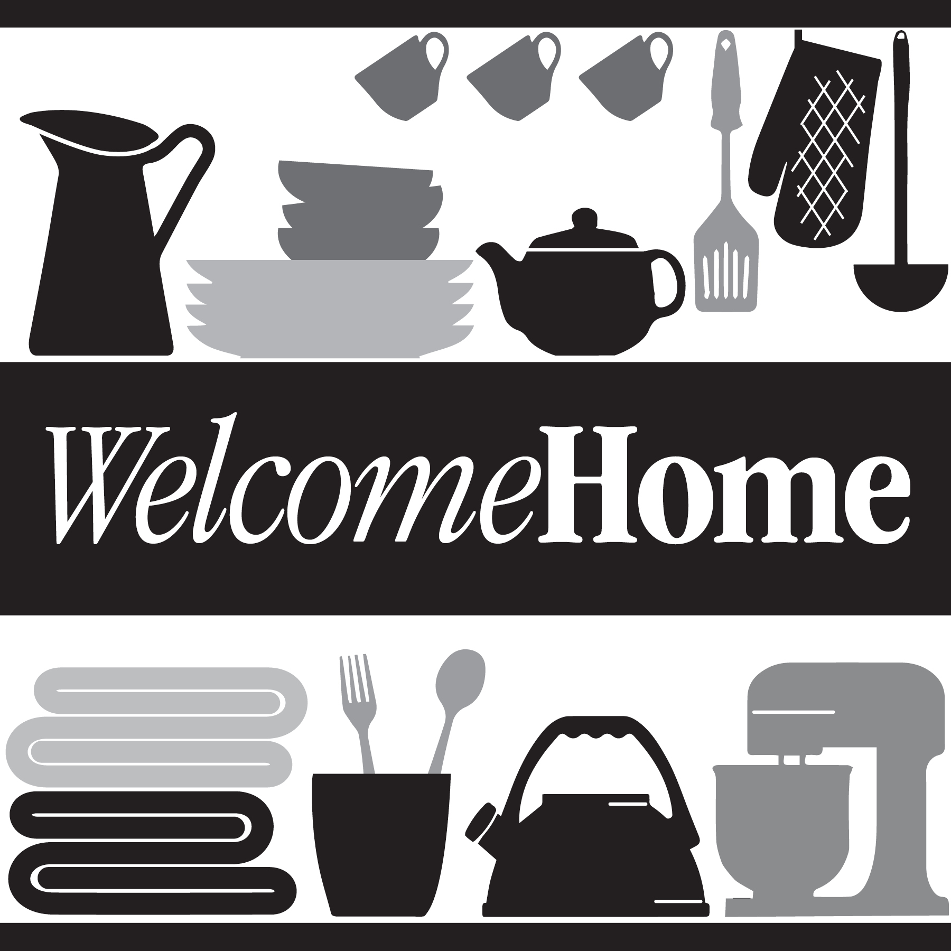

**Chestnut Hill Square Hosts Linen Donation Drive**

**to Benefit Local Non-Profit Welcome Home**

CHESTNUT HILL, MASSACHUSETTS (April 2022) - Chestnut Hill Square ([ChestnutHillSquare.com](http://www.chestnuthillsquare.com/)) will host its annual linen donation drive to benefit Welcome Home, a home goods pantry based in Newton, MA. Welcome Home provides families experiencing hardship with the basic household items they need to live with dignity.

From Monday, April 11 through Saturday, April 30**,** donations of clean, new, and like-new items (free of rips or stains), can be dropped at Athleta in Chestnut Hill Square. Items most needed include blankets, comforters, and sheets (queen size preferred), towels and new, non-decorative bed pillows. To make a monetary donation, visit [WelcomeHomeMass.org](https://www.welcomehomemass.org/welcomehomemass-838460-682780.html).

“Welcome Home works on the front lines by providing basic home goods items to families in need with no fees, forms, or requirements. Many of our clients are leaving shelters for permanent housing, and new immigrants to our communities. We are expecting our first Ukrainian families in the coming weeks and are so grateful for our continued partnership with Chestnut Hill Square," shared Julie Plaut Mahoney, Executive Director of Welcome Home.

“Welcome Home is a wonderful organization that is making a difference by providing home goods to our neighbors in need. Chestnut Hill Square is pleased to continue our partnership with Welcome Home, and we look forward to a successful linen donation drive,” says Rebekah Macchia, Marketing Director of Chestnut Hill Square.

**Chestnut Hill Square**

Chestnut Hill Square is an exciting lifestyle destination on Route 9 in Chestnut Hill, Massachusetts that features popular shops such as Massachusetts’ first Serena & Lily, Anthropologie/BHLDN, Free People, Athleta, and more. Dining selections include Seasons 52, The Capital Grille, sweetgreen, Oath Pizza and Starbucks. Wegmans and Wegmans Wine, Liquor & Beer provide customers with the area’s best grocery shopping, while Equinox, Precision Running Lab by Equinox, SoulCycle, and Lunette Optic offer sought-after fitness and health options. Chestnut Hill Square’s Medical Office Building includes Beth Israel Deaconess HealthCare-Chestnut Hill, Beth Israel Lahey Health Urgent Care and eight medical offices. Chestnut Hill Square is a New England Development shopping destination. For more information, visit [ChestnutHillSquare.com](http://www.ChestnutHillSquare.com).

**New England Development**

For over forty years, New England Development has taken a creative, entrepreneurial approach to real estate development and management - delivering and sustaining successful projects across a wide range of property types. These projects transform complex challenges into preferred locations, generate long-term value to communities, afford compelling opportunities for local and national businesses, and offer sought-after experiences to a wide range of consumers.

The company is acclaimed for creating some of the country's most widely-recognized and successful regional centers, as well as multifaceted developments that combine retail, residential, hotel, and office uses. Outlet centers, high-end and street-front retail, airport retail, golf courses, restaurants, and marinas round out New England Development's robust portfolio. For more information, visit [NEDevelopment.com](http://www.NEDevelopment.com).

# # #