**Contact:**

Christie Kozak | Leary PR | [christie@learypr.com](mailto:christie@learypr.com) | 978-502-5747

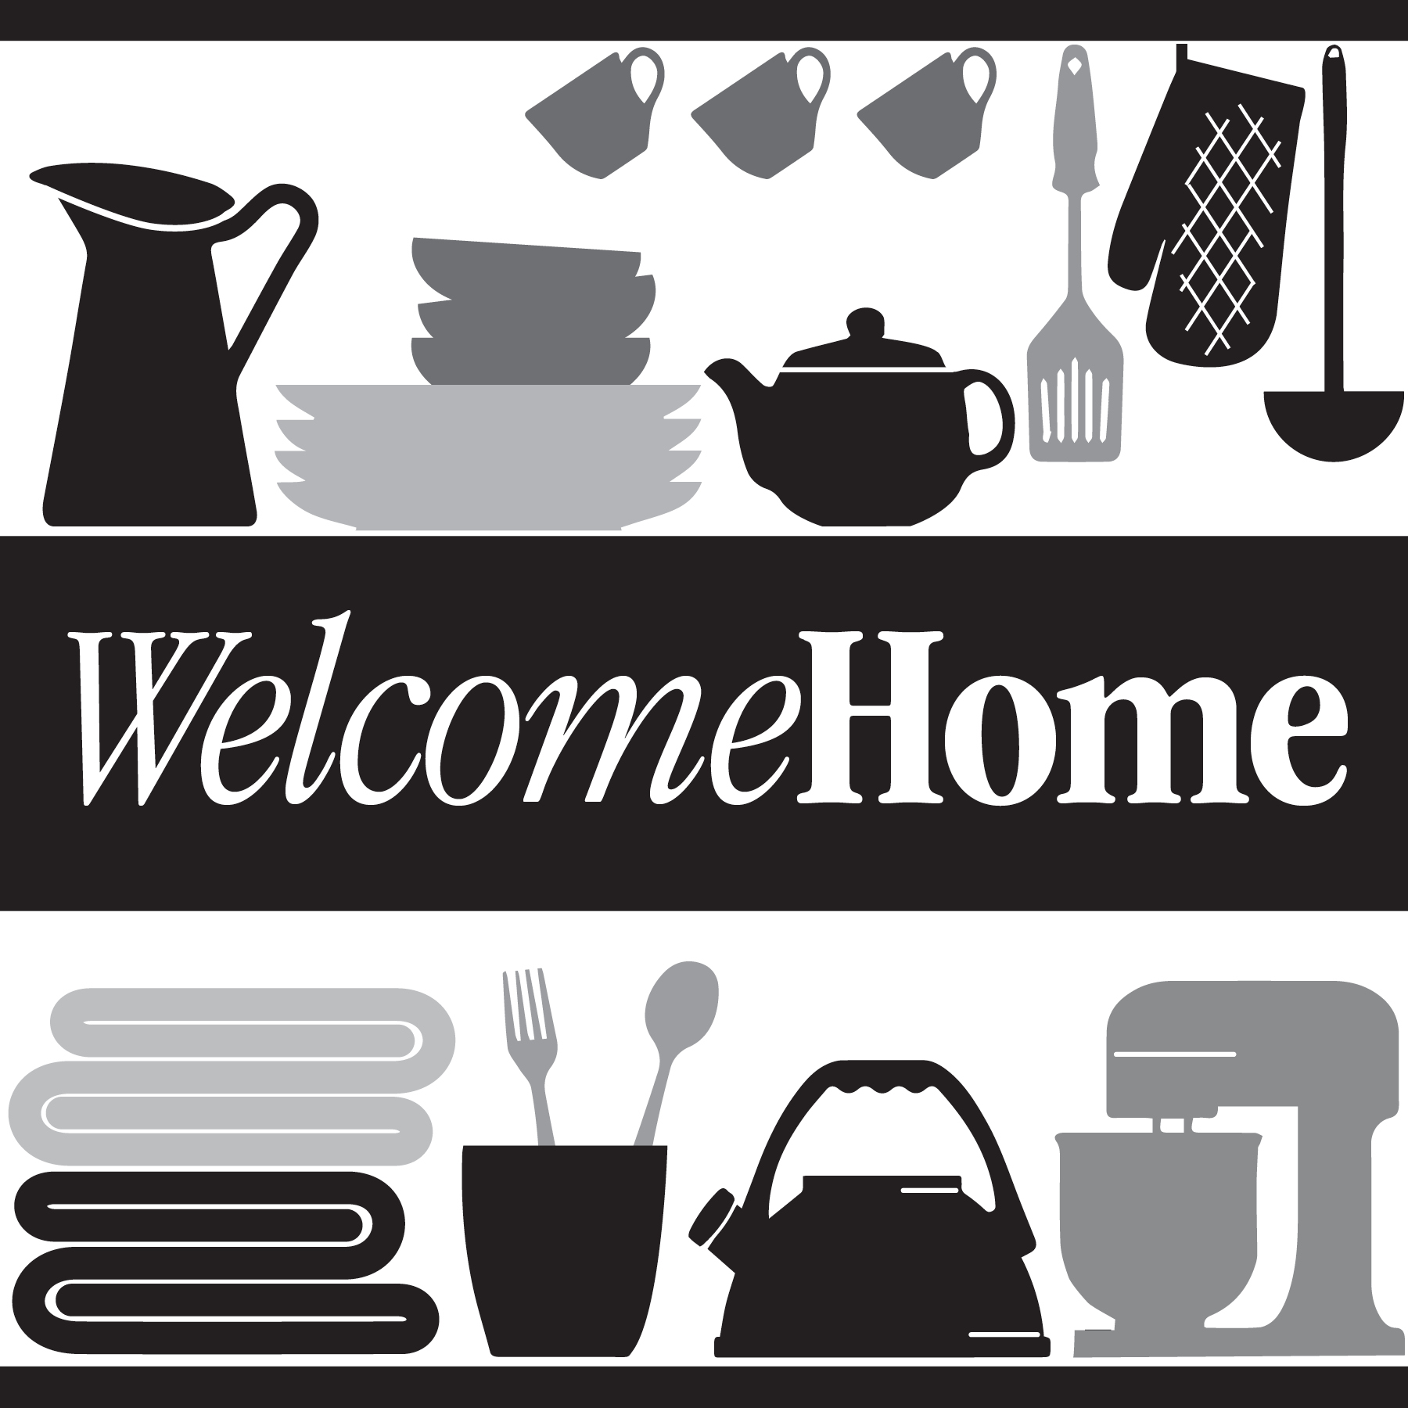

**Chestnut Hill Square Hosts March Donation Drive**

**to Benefit Local Non-Profit Welcome Home**

CHESTNUT HILL, MASSACHUSETTS (March 2021) - Chestnut Hill Square ([ChestnutHillSquare.com](http://www.chestnuthillsquare.com/)) will host a March 2021 donation drive to benefit Welcome Home, a home goods pantry based in Newton, MA. Welcome Home provides families experiencing hardship with basic household items they need to live with dignity. Welcome Home collects and redistributes like-new and new household items to dozens of people in need each month.

"Welcome Home is grateful to Chestnut Hill Square for hosting this important donation drive to help our neighbors during these challenging times,” says Julie Plaut Mahoney, Executive Director of Welcome Home.

Donations of new or gently used dish towels, bedding, pots & pans, kitchen utensils and other home goods can be dropped at Athleta or in the lobby of the Medical Office Building at Chestnut Hill Square. To give monetary donations, visit [WelcomeHomeMass.org](https://www.welcomehomemass.org/welcomehomemass-838460-682780.html).

“Chestnut Hill Square is pleased to partner with Welcome Home, a wonderful local resource providing necessary home goods to those in need in our community,” says Rebekah Macchia, Marketing Director of Chestnut Hill Square.

**Chestnut Hill Square**

Chestnut Hill Square is an exciting lifestyle destination on Route 9 in Chestnut Hill, Massachusetts that features such popular shops and restaurants as Massachusetts’ first Serena & Lily, The Shade Store, Anthropologie/BHLDN, Free People, Athleta, francesca’s and Paper Source, Seasons 52, The Capital Grille, sweetgreen, Oath Pizza and Starbucks. Wegmans and Wegmans Wine, Liquor & Beer provide customers with the area’s best grocery shopping, while Equinox, Precision Running Lab by Equinox, SoulCycle, drybar and Lunette Optic offer sought-after fitness and beauty options. Chestnut Hill Square’s Medical Office Building includes Beth Israel Deaconess HealthCare-Chestnut Hill and eight other medical offices. Chestnut Hill Square is a project of New England Development. For more information, visit [ChestnutHillSquare.com](http://www.ChestnutHillSquare.com).

**New England Development**

For over forty years, New England Development has taken a creative, entrepreneurial approach to real estate development and management - delivering and sustaining successful projects across a wide range of property types. These projects transform complex challenges into preferred locations, generate long-term value to communities, afford compelling opportunities for local and national businesses, and offer sought-after experiences to a wide range of consumers.

The company is acclaimed for creating some of the country's most widely-recognized and successful regional centers, as well as multifaceted developments that combine retail, residential, hotel, and office uses. Outlet centers, high-end and street-front retail, airport retail, golf courses, restaurants, and marinas round out New England Development's robust portfolio. For more information, visit [NEDevelopment.com](http://www.NEDevelopment.com).

# # #