**Contact:**

Christie Kozak | Leary PR | [christie@learypr.com](mailto:christie@learypr.com) | 978-502-5747

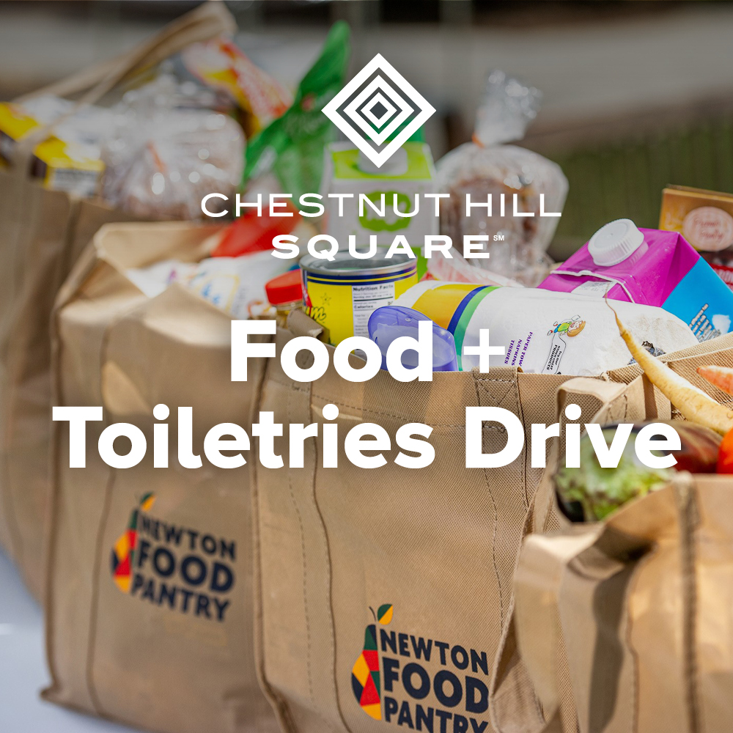

**Chestnut Hill Square Hosts Food + Toiletry Drive**

**for The Newton Food Pantry**

CHESTNUT HILL, MASSACHUSETTS (October 2022) – Chestnut Hill Square is hosting a toiletry and food drive to benefit The Newton Food Pantry. Toiletries are increasingly in demand as families struggle to make ends meet. The Newton Food Pantry is most in need of personal-care items including shampoo, toothpaste, deodorant, diapers + baby wipes as well as food items like cereal, hearty soups, tuna, ground coffee, and more. Donations can be dropped off at Starbucks now through November 16, 2022.

“We thank Chestnut Hill Square for their commitment to this important donation drive to support local families and help stock our shelves this holiday season,” says Regina Wu, President of the Newton Food Pantry. For monetary donations, please visit [NewtonFoodPantry.org.](https://newtonfoodpantry.org/)

“Chestnut Hill Square is pleased to support the Newton Food Pantry through this donation drive. This is a simple way to make a meaningful donation to our neighbors in need,” says Rebekah Macchia, Marketing Director for Chestnut Hill Square. For more information, and a full list of needed items, visit [ChestnutHillSquare.com](http://www.chestnuthillsquare.com/).

**The Newton Food Pantry**

The Newton Food Pantry is the oldest and largest food pantry in Newton, powered by volunteers since 1983. The Newton Food Pantry aims to alleviate food insecurity in the City of Newton by providing supplemental food and personal care products to community members in need, and serve clients with dignity, compassion, and respect. The organization believes no one deserves to go hungry, and everyone has the right to nutritious food. The Newton Food Pantry’s mission is to address food insecurity with a community-based approach and value equity and inclusion.

**Chestnut Hill Square**

Chestnut Hill Square is an exciting lifestyle destination on Route 9 in Chestnut Hill, Massachusetts that features popular shops such as Massachusetts’ first Serena & Lily, Anthropologie/BHLDN, Free People, Athleta, and more. Dining selections include Seasons 52, The Capital Grille, sweetgreen, Oath Pizza and Starbucks. Wegmans and Wegmans Wine, Liquor & Beer provide customers with the area’s best grocery shopping, while Equinox, Precision Running Lab by Equinox, SoulCycle, and Lunette Optic offer sought-after fitness and health options. Chestnut Hill Square’s Medical Office Building includes Beth Israel Deaconess HealthCare-Chestnut Hill, Beth Israel Lahey Health Urgent Care and eight medical offices. Chestnut Hill Square is a New England Development shopping destination. For more information, visit [ChestnutHillSquare.com](http://www.ChestnutHillSquare.com).

**New England Development**

For over forty years, New England Development has taken a creative, entrepreneurial approach to real estate development and management - delivering and sustaining successful projects across a wide range of property types. These projects transform complex challenges into preferred locations, generate long-term value to communities, afford compelling opportunities for local and national businesses, and offer sought-after experiences to a wide range of consumers.

The company is acclaimed for creating some of the country's most widely-recognized and successful regional centers, as well as multifaceted developments that combine retail, residential, hotel, and office uses. Outlet centers, high-end and street-front retail, airport retail, golf courses, restaurants, and marinas round out New England Development's robust portfolio. For more information, visit [NEDevelopment.com](http://www.NEDevelopment.com).

# # #