Contact:
Christie Kozak | Leary PR | christie@learypr.com | 978-502-5747

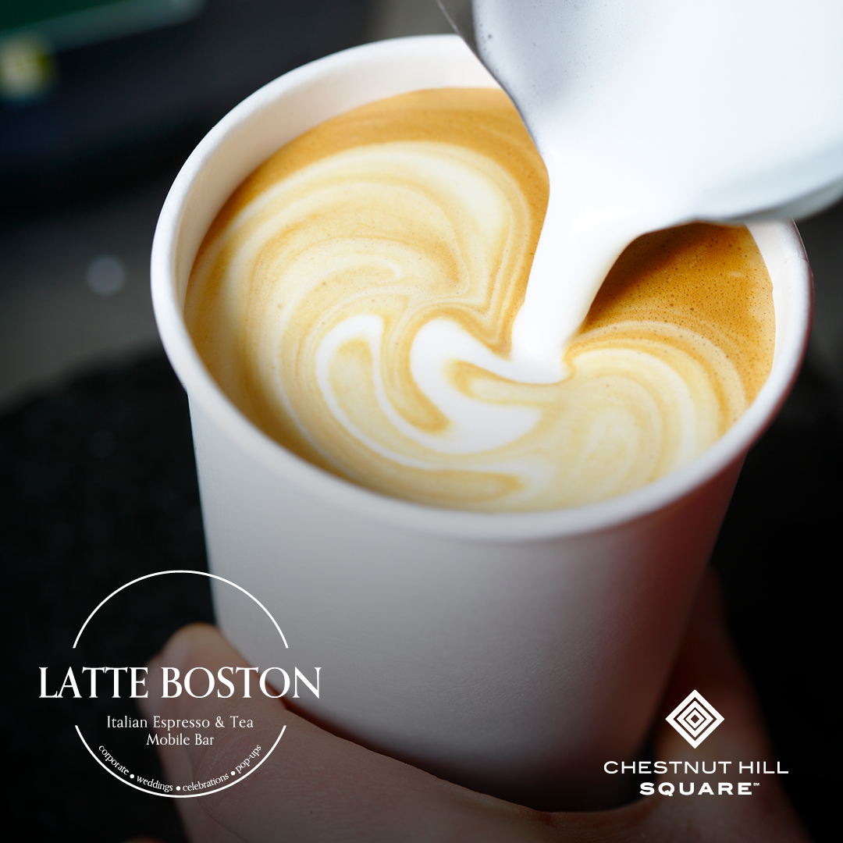

Latte Boston Popup Now Open at Chestnut Hill Square

CHESTNUT HILL, MASSACHUSETTS (July 2024) - Chestnut Hill Square has announced the summer arrival of Latte Boston, a popup mobile Italian Espresso & Tea Mobile Bar. Visitors will find Latte Boston at the center located in the parking lot across from drybar seven days a week, Monday through Friday from 7:00 a.m. to 5:00 p.m. and Saturday and Sunday from 9:00 a.m. to 5:00 p.m.* through Summer 2024.

Serving Italian premium illy Caffè and Dammann Frères tea, as well as Italian pastries. Latte Boston brings the famed Italian coffee culture to guests throughout the greater Boston area with its special events and scheduled popups.

“Coffee is deeply entrenched in the Italian way of life. The ritual of enjoying a cup of coffee extends far beyond the mere act of consuming caffeine; it is a social custom, a cherished tradition, and a hallmark of Italian identity. We look forward to our guests exploring this rich culture and hospitality with us at Latte Boston,” says Giovanni Di Ronza, Owner.

“Chestnut Hill Square is delighted for the summer arrival of Latte Boston. This charming mobile coffee and tea bar serves flavorful beverages in the true traditions of Italy,” says Rebekah Macchia, Marketing Director for Chestnut Hill Square.

(*Schedule subject to change without notice.)

Chestnut Hill Square
Chestnut Hill Square is an exciting lifestyle destination on Route 9 in Chestnut Hill, Massachusetts that features popular shops such as Massachusetts’ first Serena & Lily, Anthropologie/BHLDN, Free People, Athleta, and more. Dining selections include Seasons 52, The Capital Grille, sweetgreen, and Starbucks. Wegmans and Wegmans Wine, Liquor & Beer provide customers with the area’s best grocery shopping, while Equinox, Precision Running Lab by Equinox, SoulCycle, Lunette Optic, and Glowbar (opening soon) offer sought-after fitness and health options. Chestnut Hill Square’s Medical Office Building includes Beth Israel Deaconess HealthCare-Chestnut Hill, Beth Israel Lahey Health Urgent Care and eight medical offices. Chestnut Hill Square is a New England Development shopping destination. For more information, visit ChestnutHillSquare.com.

New England Development
For over 50 years, New England Development has taken a creative, entrepreneurial approach to real estate development and management, delivering, and sustaining successful projects across a wide range of property types. The company’s national portfolio includes mixed-use developments that combine retail, residential, office, lab and hotel use, outlet centers, high-end and street-front retail, airport retail, hotels, golf courses, restaurants, and marinas. New England Development’s diverse portfolio includes CambridgeSide in Cambridge, MA, Chestnut Hill Square in Chestnut Hill, MA, Outlets of Des Moines in Altoona, IA, Clarksburg Premium Outlets in Clarksburg, MD, Newburyport Development and Marinas, Nantucket Island Retail and The White Elephant Resorts, among others. For more information, visit NEDevelopment.com.

# # #

