**Contact:**

Christie Kozak | Leary PR | [christie@learypr.com](mailto:christie@learypr.com) | 978-502-5747

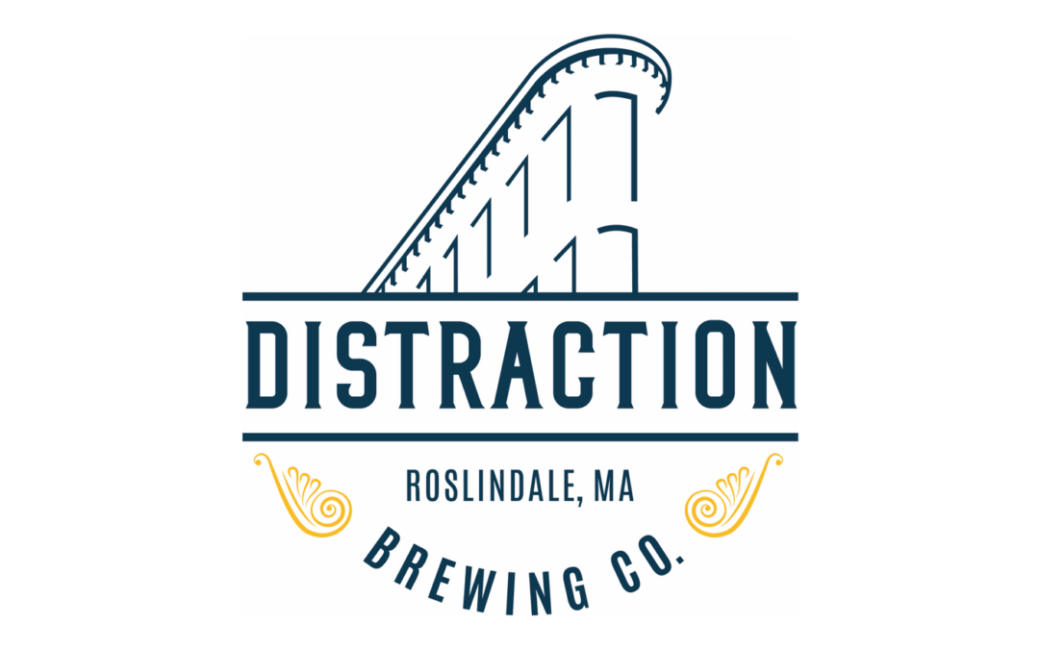

**Chestnut Hill Square Welcomes**

**Distraction Brewing Company Beer Garden**

***Beer Garden Opens Saturday, August 28 for Weekends through Fall 2021***

CHESTNUT HILL, MASSACHUSETTS (August 2021) – Chestnut Hill Square ([ChestnutHillSquare.com](http://www.ChestnutHillSquare.com)) has announced the Saturday, August 28 opening of the Distraction Brewing Company Beer Garden at the center. The outdoor craft brewery will be open weekends from 12 noon to 9:00 p.m., weather permitting, through the fall.

Distraction will serve up the brewery’s locally-made craft beers including Raspberry Wundertart, Hoppily Distracted, Passion Fruit Daydream and Hopendipity. Canned beers will also be offered. Beer selections will rotate as different brews become available. Centrally located at Chestnut Hill Square, the Distraction Beer Garden will be a lively, engaging stop for shoppers throughout the day and evening. Visitors are welcome to bring takeout dining from any of Chestnut Hill Square’s eateries including Oath Pizza, sweetgreen, and more.

Distraction Brewing Company is a small craft brewery located in Roslindale Square. Opened in late fall 2019, Distraction brews can be found in many Boston area restaurants as well as in a wide array of local liquor stores.For more information, visit [DistractionBrewingCo.com](http://www.DistractionBrewingCo.com).

“We are pleased to welcome Distraction Beer Garden to Chestnut Hill Square,” says Rebekah Macchia, Marketing Director of Chestnut Hill Square. “The Beer Garden is a fun spot to pop in and enjoy locally made beers while gathering with friends or family,” she adds.

**About Distraction Brewing Co.**

Distraction Brewing Co. is a small, family-run craft brewery in Boston, MA. Its charming Roslindale Square storefront, once operating as a bank, now serves up a rotating selection of handcrafted draft and canned beers, its proprietary maltini cocktails, and light fare featuring snacks and bites from some of Boston’s best chefs. Since opening in 2019, the 75-seat taproom and outdoor beer garden run by husband and wife duo, Mike and Lora Estey, hosts several rotating pop-up events, entertainment, and music. Distraction Brewing is the perfect place for after-work drinks with friends, family, and coworkers, and is also available for private events. Distraction Brewing is located at [2 Belgrade Avenue, Boston, MA 02131](https://www.google.com/maps/search/2+Belgrade+Avenue,+Boston,+MA+02131?entry=gmail&source=g). For hours of operation, or for more information, please call (617) 477-3637 or visit [DistractionBrewingCo.com](http://distractionbrewingco.com). 

**Chestnut Hill Square**

Chestnut Hill Square is an exciting lifestyle destination on Route 9 in Chestnut Hill, Massachusetts that features popular shops such as Massachusetts’ first Serena & Lily, Anthropologie/BHLDN, Free People, Athleta, and more. Dining selections include Seasons 52, The Capital Grille, sweetgreen, Oath Pizza and Starbucks. Wegmans and Wegmans Wine, Liquor & Beer provide customers with the area’s best grocery shopping, while Equinox, Precision Running Lab by Equinox, SoulCycle, and Lunette Optic offer sought-after fitness and health options. Chestnut Hill Square’s Medical Office Building includes Beth Israel Deaconess HealthCare-Chestnut Hill, Beth Israel Lahey Health Urgent Care and eight medical offices. Chestnut Hill Square is a New England Development shopping destination. For more information, visit [ChestnutHillSquare.com](http://www.ChestnutHillSquare.com).

**New England Development**

For over forty years, New England Development has taken a creative, entrepreneurial approach to real estate development and management - delivering and sustaining successful projects across a wide range of property types. These projects transform complex challenges into preferred locations, generate long-term value to communities, afford compelling opportunities for local and national businesses, and offer sought-after experiences to a wide range of consumers.

The company is acclaimed for creating some of the country's most widely-recognized and successful regional centers, as well as multifaceted developments that combine retail, residential, hotel, and office uses. Outlet centers, high-end and street-front retail, airport retail, golf courses, restaurants, and marinas round out New England Development's robust portfolio. For more information, visit [NEDevelopment.com](http://www.NEDevelopment.com).

# # #