**Contact:**

Christie Kozak | Leary PR | [christie@learypr.com](mailto:christie@learypr.com) | 978-502-5747

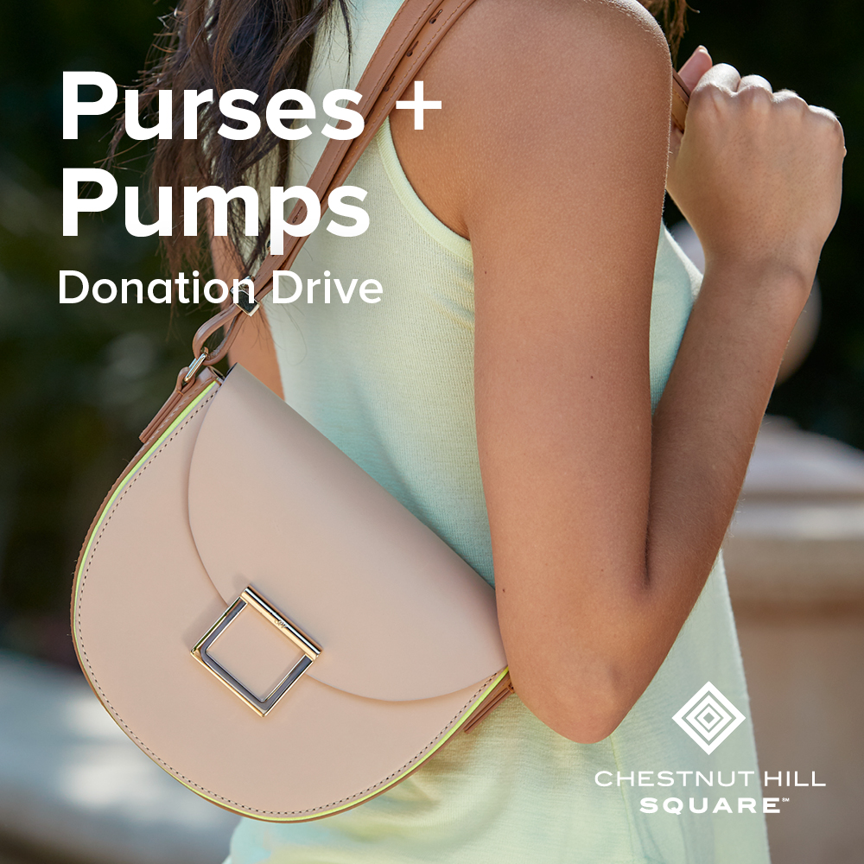

**Chestnut Hill Square to Host Purses & Pumps Donation Drive**

**to Benefit Dress for Success Boston**

***Now through Sunday, May 30, 2021***

CHESTNUT HILL, MASSACHUSETTS (May 2021) – Chestnut Hill Square ([ChestnutHillSquare.com](http://www.ChestnutHillSquare.com)) is teaming with Dress for Success Boston to host a Purses & Pumps Donation Drive through Sunday, May 30, 2021. Donations of new purses and women’s professional shoes including flats and modest heels (no mules, stilettos, or sandals please) can be dropped in the lobby of the Medical Office Building at Chestnut Hill Square or at Athleta.

All donations benefit Dress for Success Boston. The mission of Dress for Success is to empower women to achieve economic independence by providing a network of support, professional attire and then development tools to help them thrive in work and in life. The need has never been greater. For more information, or to make an online donation, visit [DressForSuccessBoston](https://boston.dressforsuccess.org/).

“Purses & Pumps is an important donation drive to benefit Dress for Success and help assist women re-entering the workforce in our community,” says Rebekah Macchia, Marketing Director of Chestnut Hill Square.

Dress for Success Boston is an affiliate of the Worldwide Dress for Success organization, with over 150 affiliates in 20 countries. Started in 2001 by Co-Founders Nancy Schneider and Enith Levine, to date Dress for Success Boston has served just under 15,000 women in the greater Boston area.

“The empowerment of women, with an end goal of economic independence, informs everything we do,” says Kim Todd, Executive Director of Dress for Success Boston. “We are grateful to Chestnut Hill Square for hosting this donation drive to allow us to provide our clients with professional purses and footwear for the workplace,” she adds.

**Chestnut Hill Square**

Chestnut Hill Square is an exciting lifestyle destination on Route 9 in Chestnut Hill, Massachusetts that features such popular shops and restaurants as Massachusetts’ first Serena & Lily, The Shade Store, Anthropologie/BHLDN, Free People, Athleta, francesca’s and Paper Source, Seasons 52, The Capital Grille, sweetgreen, Oath Pizza and Starbucks. Wegmans and Wegmans Wine, Liquor & Beer provide customers with the area’s best grocery shopping, while Equinox, Precision Running Lab by Equinox, SoulCycle, drybar and Lunette Optic offer sought-after fitness and beauty options. Chestnut Hill Square’s Medical Office Building includes Beth Israel Deaconess HealthCare-Chestnut Hill and eight other medical offices. Chestnut Hill Square is a project of New England Development. For more information, visit [ChestnutHillSquare.com](http://www.ChestnutHillSquare.com).

**New England Development**

For over forty years, New England Development has taken a creative, entrepreneurial approach to real estate development and management - delivering and sustaining successful projects across a wide range of property types. These projects transform complex challenges into preferred locations, generate long-term value to communities, afford compelling opportunities for local and national businesses, and offer sought-after experiences to a wide range of consumers.

The company is acclaimed for creating some of the country's most widely-recognized and successful regional centers, as well as multifaceted developments that combine retail, residential, hotel, and office uses. Outlet centers, high-end and street-front retail, airport retail, golf courses, restaurants, and marinas round out New England Development's robust portfolio. For more information, visit [NEDevelopment.com](http://www.NEDevelopment.com).

# # #