**Contact:** Christie Kozak | Leary PR | [christie@learypr.com](mailto:christie@learypr.com) | 978-502-5747

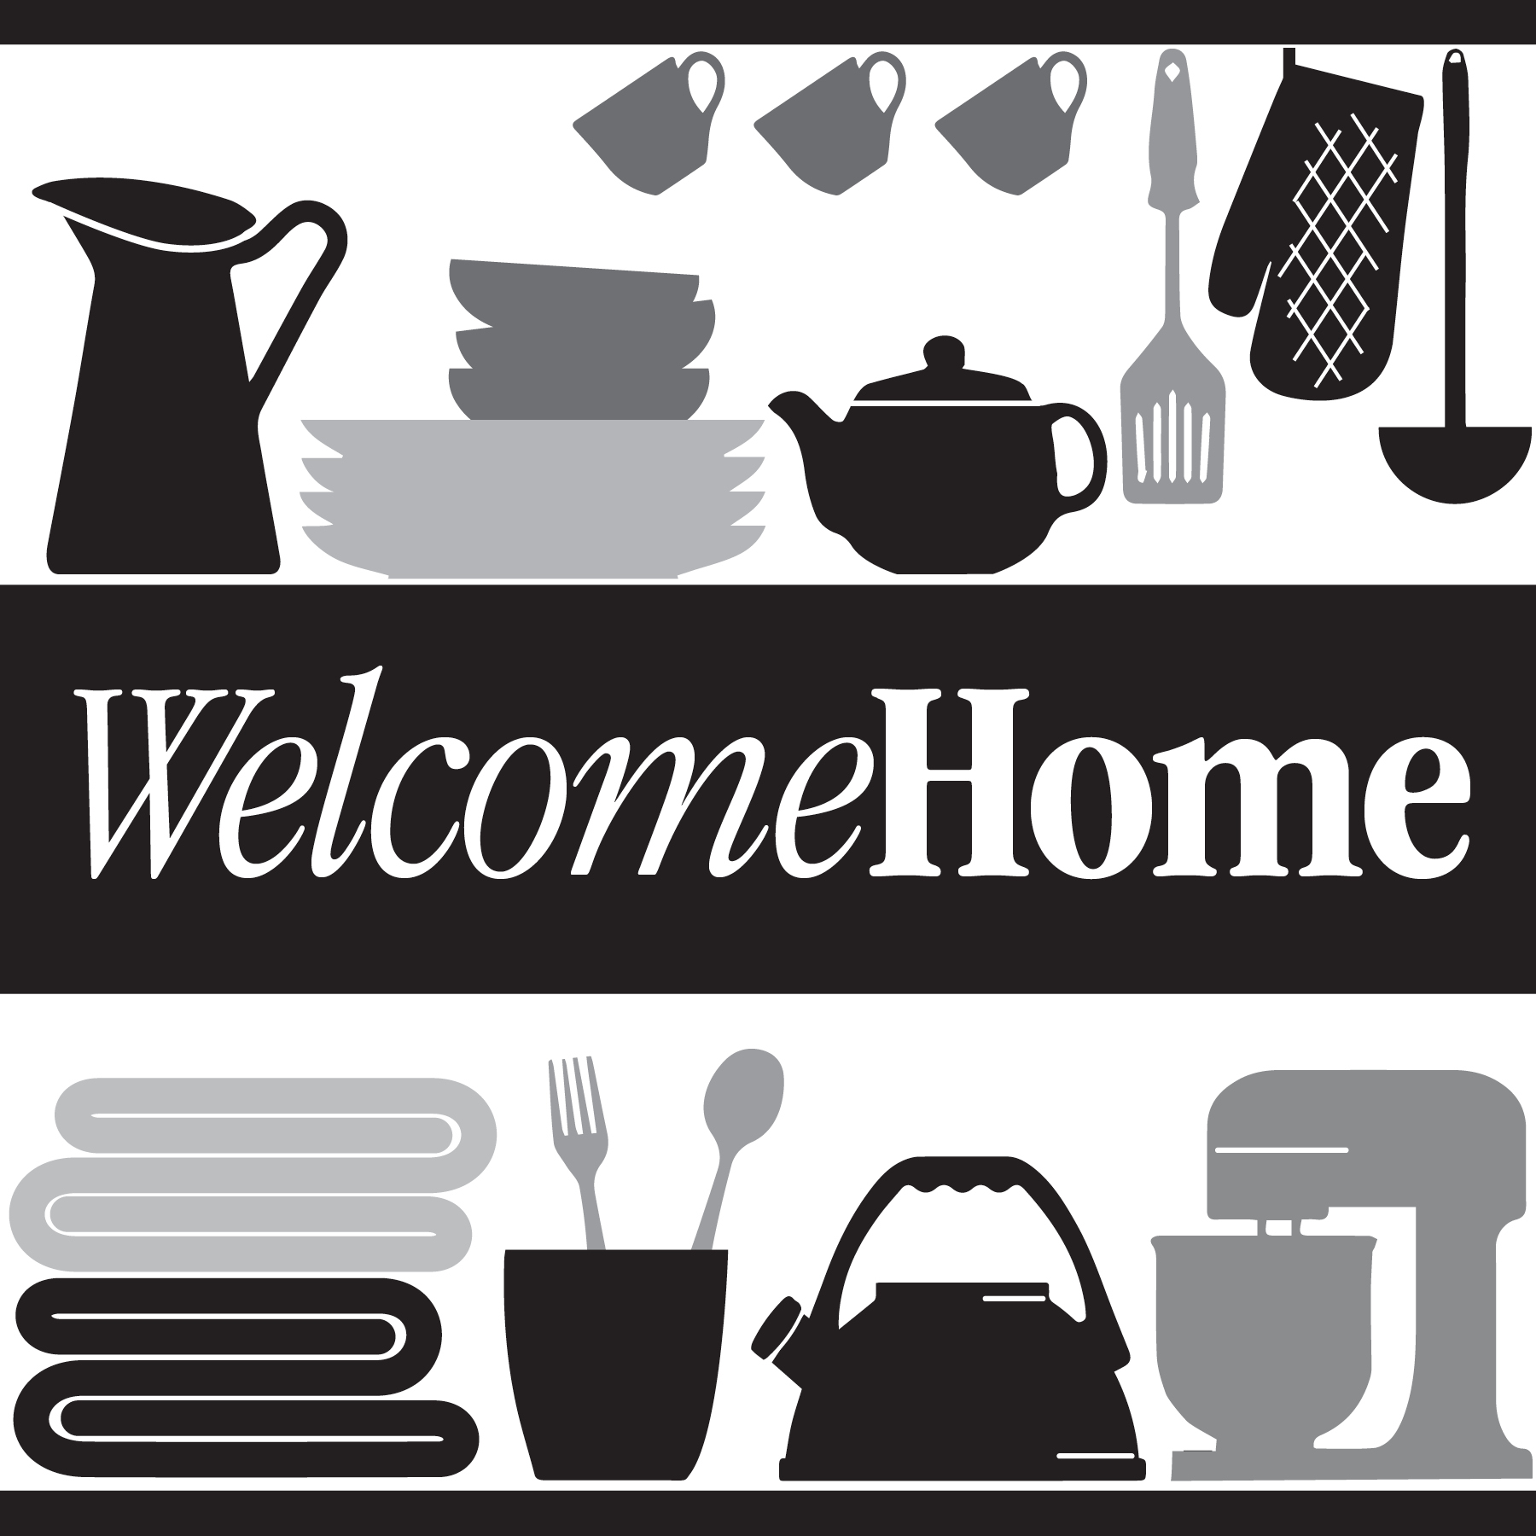

**Chestnut Hill Square Hosts Bedding and Bath Donation Drive**

**to Benefit Local Non-Profit Welcome Home**

CHESTNUT HILL, MASSACHUSETTS (October 2021) - Chestnut Hill Square ([ChestnutHillSquare.com](http://www.chestnuthillsquare.com/)) is hosting a Bedding and Bath donation drive to benefit Welcome Home, a local home goods pantry based in Newton, Massachusetts, through October 31, 2021. Welcome Home provides families experiencing hardship with basic household items they need to live with dignity. Welcome Home collects and redistributes like-new and new household items to dozens of people in need each month.

Chestnut Hill Square is collecting new or gently used bath towels, queen and king sheet sets, comforters, and blankets. Items can be dropped in the marked bins at Athleta or in the Medical Office Building lobby. Throughout the drive Athleta will offer donors $15.00 off any item purchased the day the donation is received in store.

Julie Plaut Mahoney, Executive Director of Welcome Home shares, "We are truly grateful to Chestnut Hill Square and Athleta for supporting our Bedding and Bath donation drive as we prepare to meet the needs of families during the coming cold winter months." For more information about Welcome Home, or to give monetary donations, visit [WelcomeHomeMass.org](https://www.welcomehomemass.org/welcomehomemass-838460-682780.html).

“We are excited to once again partner with Welcome Home to collect these bedding and bath items to help our neighbors during these challenging times,” says Rebekah Macchia, Marketing Director of Chestnut Hill Square.

**Chestnut Hill Square**

Chestnut Hill Square is an exciting lifestyle destination on Route 9 in Chestnut Hill, Massachusetts that features popular shops such as Massachusetts’ first Serena & Lily, Anthropologie/BHLDN, Free People, Athleta, and more. Dining selections include Seasons 52, The Capital Grille, sweetgreen, Oath Pizza and Starbucks. Wegmans and Wegmans Wine, Liquor & Beer provide customers with the area’s best grocery shopping, while Equinox, Precision Running Lab by Equinox, SoulCycle, and Lunette Optic offer sought-after fitness and health options. Chestnut Hill Square’s Medical Office Building includes Beth Israel Deaconess HealthCare-Chestnut Hill, Beth Israel Lahey Health Urgent Care and eight medical offices. Chestnut Hill Square is a New England Development shopping destination. For more information, visit [ChestnutHillSquare.com](http://www.ChestnutHillSquare.com).

**New England Development**

For over forty years, New England Development has taken a creative, entrepreneurial approach to real estate development and management - delivering and sustaining successful projects across a wide range of property types. These projects transform complex challenges into preferred locations, generate long-term value to communities, afford compelling opportunities for local and national businesses, and offer sought-after experiences to a wide range of consumers.

The company is acclaimed for creating some of the country's most widely-recognized and successful regional centers, as well as multifaceted developments that combine retail, residential, hotel, and office uses. Outlet centers, high-end and street-front retail, airport retail, golf courses, restaurants, and marinas round out New England Development's robust portfolio. For more information, visit [NEDevelopment.com](http://www.NEDevelopment.com).

# # #