Contact:
Christie Kozak | Leary PR | christie@learypr.com | 978-502-5747

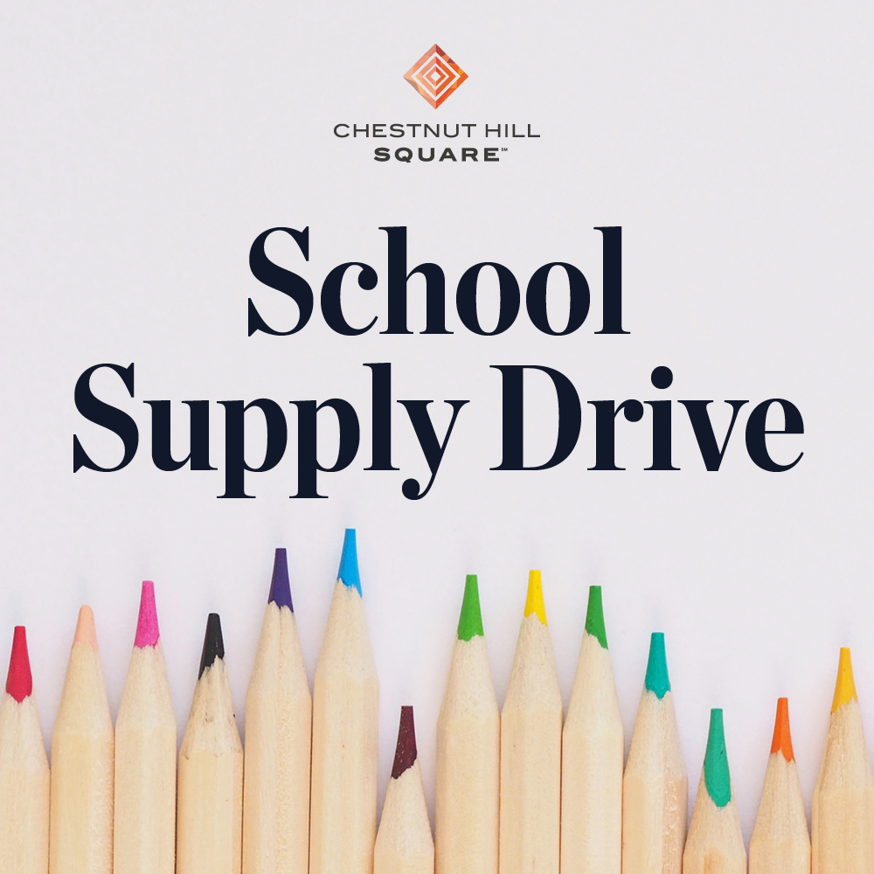

Chestnut Hill Square Hosts School Supply Drive for
School on Wheels of Massachusetts

Donations accepted through August 25, 2024

CHESTNUT HILL, MA (July 2024) – Chestnut Hill Square is hosting a School Supply Donation Drive for School on Wheels of Massachusetts now through August 25, 2024. Donations can be dropped off in the marked donation bin located at Free People. For more information, visit ChestnutHillSquare.com.

Donations of need include new, unused backpacks, pencils & pencil sharpeners, blue or black inked pens, pencil pouches, glue sticks, plastic rulers, washable markers, composition notebooks and more. 100% of the proceeds will benefit School on Wheels of Massachusetts, whose mission is to support the academic, social, and emotional growth of students impacted by homelessness. Online donations to purchase school supplies can be made at SOWMA.org.

“The backpack and school supplies we provide support both the child and their family during the most difficult times. Our backpack serves as a lifeline, helping children succeed in the classroom while offering social and emotional support during uncertain times. By providing a quality backpack loaded with essentials, we assure the student that they are important and seen. This can make all the difference as they begin the new school year,” explains Barbara Fox, Community Outreach Director for School on Wheels.

“Chestnut Hill Square is happy to continue our partnership with School on Wheels of Massachusetts and support the School Supply Drive in helping children in our community return to school with the supplies they need,” says Rebekah Macchia, Marketing Director of Chestnut Hill Square.

About School on Wheels of Massachusetts
School on Wheels of Massachusetts (SOWMA) was founded in 2004 to bring one-on-one academic support to children struggling to stay on track and in school while experiencing homelessness. Since the start of the 2020/2021 academic year, SOWMA has distributed more than 6,000 new customized, grade-level backpacks to children and at-risk youth living in 38 Massachusetts communities. Trained volunteers provide one-on-one tutoring to 280 students at 18 program site locations from Boston to the South Coast. The Bridge Mentoring Program provides 57 high school and college-age students with a volunteer mentor, who shepherds students through high school and onto post-secondary plans, including college, vocational training, and jobs.
For more information, visit SOWMA.org.

Chestnut Hill Square
Chestnut Hill Square is an exciting lifestyle destination on Route 9 in Chestnut Hill, Massachusetts that features popular shops such as Massachusetts’ first Serena & Lily, Anthropologie/BHLDN, Free People, Athleta, and more. Dining selections include Seasons 52, The Capital Grille, sweetgreen, and Starbucks. Wegmans and Wegmans Wine, Liquor & Beer provide customers with the area’s best grocery shopping, while Equinox, Precision Running Lab by Equinox, SoulCycle, Lunette Optic, and Glowbar (opening soon) offer sought-after fitness and health options. Chestnut Hill Square’s Medical Office Building includes Beth Israel Deaconess HealthCare-Chestnut Hill, Beth Israel Lahey Health Urgent Care and eight medical offices. Chestnut Hill Square is a New England Development shopping destination. For more information, visit ChestnutHillSquare.com.

New England Development
For over 50 years, New England Development has taken a creative, entrepreneurial approach to real estate development and management, delivering, and sustaining successful projects across a wide range of property types. The company’s national portfolio includes mixed-use developments that combine retail, residential, office, lab and hotel use, outlet centers, high-end and street-front retail, airport retail, hotels, golf courses, restaurants, and marinas. New England Development’s diverse portfolio includes CambridgeSide in Cambridge, MA, Chestnut Hill Square in Chestnut Hill, MA, Outlets of Des Moines in Altoona, IA, Clarksburg Premium Outlets in Clarksburg, MD, Newburyport Development and Marinas, Nantucket Island Retail and The White Elephant Resorts, among others. For more information, visit NEDevelopment.com.

# # #

