Contact:
Christie Kozak | Leary PR | christie@learypr.com | 978-502-5747

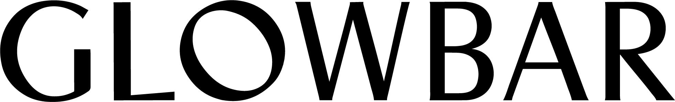

Chestnut Hill Square Announces Summer Opening of Glowbar

Newton, MA Native Rachel Liverman, CEO and Founder
Brings Facial Membership Brand to Hometown

CHESTNUT HILL, MA (May 2024) – Chestnut Hill Square has announced the summer opening of Glowbar, the beloved facial-membership brand whose 30-minute, affordable, custom, and results-driven treatments have made it an East Coast skincare staple.

Rachel Liverman, a Newton, MA native, and the CEO & Founder of Glowbar comes from a family of skincare pioneers. In 1977, her grandmother, Catherine Hinds, founded the first fully-accredited esthetics school in Woburn, Massachusetts — an institution that still thrives today — pioneering the way for millions of women to learn the importance of skin maintenance through regular facials. Rachel is continuing this family legacy with Glowbar, driven by a mission to provide accessible skincare that helps everyone feel confident in their skin.

“We’re bringing the glow to Boston — and carrying our mission of instilling confidence through easy, expert skincare to town along with us,” says Rachel. “This studio opening holds extra significance as I honor my grandmother’s legacy by introducing Glowbar to where it all started.”

Quickly expanding across New York, Connecticut, New Jersey, Pennsylvania, and now Massachusetts, Glowbar is revolutionizing the skincare industry. Liverman has coined this phenomenon, “wellcare,” the next generation of specialized care offering an easy, convenient path to feeling your best. Glowbar’s method addresses the demand for consistent and reliable treatments without complicated menus and surprise up-charges. Glowbar’s flat rate of $60 for members and $75 for stand-alone appointments offer tailored facials that include extractions, dermaplaning, cavitation, microcurrent, high frequency, chemical peels, or LED.

“Chestnut Hill Square is pleased to announce the summer opening of Glowbar. Glowbar’s unique concept makes booking expert-level skincare more accessible than ever, and their services are the perfect complement to our center’s health and beauty offerings,” says Rebekah Macchia, Marketing Director for Chestnut Hill Square.

About Glowbar
Glowbar is revolutionizing the skincare industry with 30-minute, affordable, customized, and solution-oriented facial treatments with 8 locations in New York, as well as locations in Philadelphia, New Jersey, and Connecticut. Called “the custom facial that leaves your skin glowing” by “Town & Country,” Glowbar has become the must-visit monthly retreat for those looking to keep their skin in great shape under the care of skincare experts, all without the anxiety of overwhelming treatment menus, and the need for expensive add-ons. Founded in 2019 by third-generation esthetician Rachel Liverman, Glowbar has delivered the glow to nearly 250,000 people to date. Stay up to date on the latest with the Glowbar Boston openings and Founding memberships by visiting: Back Bay and Chestnut Hill. Follow Glowbar on Instagram and TikTok for skincare tips and to be the first to know about special offers and new locations.

Chestnut Hill Square
Chestnut Hill Square is an exciting lifestyle destination on Route 9 in Chestnut Hill, Massachusetts that features popular shops such as Massachusetts’ first Serena & Lily, Anthropologie/BHLDN, Free People, Athleta, and more. Dining selections include Seasons 52, The Capital Grille, sweetgreen, and Starbucks. Wegmans and Wegmans Wine, Liquor & Beer provide customers with the area’s best grocery shopping, while Equinox, Precision Running Lab by Equinox, SoulCycle, and Lunette Optic offer sought-after fitness and health options. Chestnut Hill Square’s Medical Office Building includes Beth Israel Deaconess HealthCare-Chestnut Hill, Beth Israel Lahey Health Urgent Care and eight medical offices. Chestnut Hill Square is a New England Development shopping destination. For more information, visit ChestnutHillSquare.com.

New England Development
For over 50 years, New England Development has taken a creative, entrepreneurial approach to real estate development and management, delivering, and sustaining successful projects across a wide range of property types. The company’s national portfolio includes mixed-use developments that combine retail, residential, office, lab and hotel use, outlet centers, high-end and street-front retail, airport retail, hotels, golf courses, restaurants, and marinas. New England Development’s diverse portfolio includes CambridgeSide in Cambridge, MA, Chestnut Hill Square in Chestnut Hill, MA, Outlets of Des Moines in Altoona, IA, Clarksburg Premium Outlets in Clarksburg, MD, Newburyport Development and Marinas, Nantucket Island Retail and The White Elephant Resorts, among others. For more information, visit NEDevelopment.com.

# # #

